MICROWAVE SYNTHESIS OF AMINO-PYRIMIDINES
By Prof S.Udhayavani, Prof. S.Umashankari
Department of Chemistry, Adhiparasakthi Engineering College - Melmaruvathur.
Department of Chemistry, Bharath University – Chennai
vani.udhaya@gmail.com , mswethauma80@gmail.com
ABSTRACT
Microwave assisted synthesis of 2-Aminopyrimidine has advantages due to reduced reaction time, solvent-free condition and high yield. H-NMR spectrum shows a signal in the range of 5.1-5.3 ppm and IR spectrum show bands in the range 3456-3182 cm⁻¹ due to the free amino group of compounds of 2-Amino-6-(4-methoxyphenyl)-4-(furan-2yl)pyrimidine , 2-Amino-6-[4-(dimethylamino)phenyl]-4-(furan-2yl)pyrimidine and 2-Amino-6-[3,4-(dimethoxy)phenyl]-4-furan-2ylpyrimidine
KEY WORDS: NMR, FT-IR

INTRODUCTION
Medical research has uncovered the causes and modifiers of the major chronic diseases affecting humans worldwide. In particular, cardiovascular diseases with emphasis on coronary heart disease are a major problem with high mortality¹⁻³. In addition, there are many types of cancer and fortunately the key aetiological factors have been identified ⁴⁻⁶. In virtually all of these diseases, the underlying mechanisms depend on oxidative processes leading to products that display reactive properties, affecting specific molecular targets in the vascular system and cellular DNA as regards many kinds of cancer. Specially, high titres of LDL- cholesterol represent one risk factor for heart disease. This macromolecule undergoes oxidation to the corresponding oxy derivative, in the absence of protective antioxidants⁷⁻⁸. The majority of human cancers are caused by DNA-reactive genotoxic carcinogens, modifying the DNA of normal cells. Specific DNA adducts of many kinds of carcinogens have been identified. However, since the discovery by Kasai and Nishimura⁹ that DNA also can undergo oxidative modification, particularly the formation of 8- oxydG, it has been found that most chemical carcinogens not only form the conventional DNA adducts but also generate 8-oxydG¹⁰. In addition, promotion is involved in the growth and development of many forms of cancer. In turn, these processes involve active oxygen and peroxy compounds¹¹.
During the development and growth of many types of cancer there are distinct oxidation reactions that have been documented to play a key role during that phase of carcinogenesis. Indeed, these specific reactions involve the generation of active oxygen such as OH radicals and hydrogen peroxide that in turn control the cell duplication rates, and may affect apoptotic reactions that would lead to elimination of abnormal cells. Antioxidants antagonize powerfully the developmental aspects of carcinogenesis¹²⁻¹³.
Most of the phenolic antioxidants currently used in medicine (vitamin E, ubiquinone, probucol) belong to lipophilic compounds, while the number of known water-soluble drug forms is very restricted. However, the lipophilic character of phenolic antioxidants reduces the velocity of their transport in the organism and decreases penetration into tissues and cells, which can restrict the drug efficacy in urgent cases of free-radical pathologies such as ischemia reperfusion, radiation damage, acute respiratory distress syndrome, or intoxication with hepatotropic poisons. Moreover, since the oxidation processes in living organisms proceed in both lipid (cell membranes, lipoproteins) and aqueous phases, the most effective approach consists in using a combination of fat- and water-soluble antioxidants ¹⁴.
Pyrimidine is a basic nucleus in nucleic acids and has been associated with a number of biological activities¹⁵. Substituted pyrimidines and their derivatives are also well known to have a number of biological, antimicrobical and pharmaceutical activities¹⁶.
RESULT AND DISCUSSION
SYNTHESIS
Some 2-amino-6-aryl-4-(furan-2yl)pyrimidines were obtained in two steps using microwave technique. First step involves Claisen-Schmidt condensation of 1-(2-firanyl)ethanone 1 with a suitably substituted benzaldehyde 2 in presence of sodium hydroxide to yield 3-Aryl-1-(2-furanly)prop-2-en-1-one (scheme-1).
Where,
X=4-OCH₃ (1)
X=4-N(CH₃)₂ (2)
X=3,4-OCH₃ (3)
A
1-3
B
As show in scheme-2,
2-amino-6-aryl-4-(furan-2yl)pyrimidines 1-3 were obtained by treatment of 1-3 with guanidine hydrochloride in presence of sodium hydroxide. These compounds were characterized using IR and NMR.
2-Amino-6(4-methoxyphenyl)-4-(furan-2yl) pyrimidine (1A)

1A-3A
Where,
X=4-OCH₃ (1A)
X=4-N(CH₃)₂ (2A)
X=3,4-OCH₃ (3A)

Analysis of ¹H NMR spectrum
The ¹H NMR spectrum of 1 is given in plate 1A. The singlet for two protons at 5.14 ppm is assigned to the amino protons. The singlet for the H-5 proton is observed at 7.59ppm. Other aromatic protons resonate in the region of 6.5 – 8.0 ppm. A singlet centered at 3.87 ppm is due to methoxy protons.
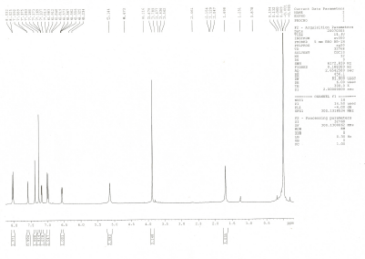

Analysis of ¹³C spectrum
The ¹³C spectrum of 1 is displayed in plate 1A. The signal at 101.3 ppm is assigned to C-5. The signal observed at 163.2 ppm is assigned to C-2. The signal at 161.7 and 165.5 ppm are due to C-6 and C-4 carbons. The signal observed at 129.7 ppm is due to phenyl quaternary carbon attached to the pyrimidine ring. The signal observed at 55.4 ppm is due to carbon of the methoxy group. The signal observed at 152.3 ppm is due to furanyl quaternary carbon attached to the pyrimidine ring. The signals observed at 144.4, 112.1 and 111.3 ppm are due to C-a,C-b and C-c carbons of the furan ring. The signals observed at 128.5, 114.0 and 156.7 ppm are assigned to C-a’, C-b’ and C-c’ carbons of the phenyl ring.
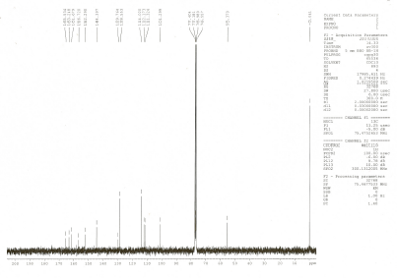

Analysis of FT-IR spectrum
The FT-IR spectrum of 1 is displayed in plate 1A. The absorptions at 3324.7 3184.5 cm⁻¹ are due to N-H asymmetric and symmetric stretching vibrations of the primary amino group. The weak absorption at 2935.1 cm⁻¹ is assigned to aromatic C-H stretching vibration. The band at 1649.5 cm⁻¹ indicates N-H in-plane bending vibrations of the primary amino group. The absorption band at 1235.8 cm⁻¹ is due to C-N stretching vibration. The C-H out-of-plane bending vibration in 2-substituted furan is observed at 820.1 cm⁻¹.
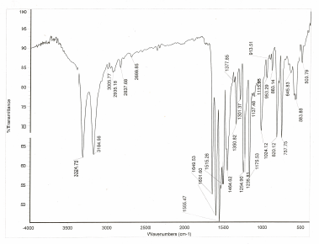

2-Amino-6-[4-(dimethylamino) phenyl)]-4-(furan-2yl)pyrimidine (2A)
Analysis of ¹H NMR spectrum
The ¹H NMR spectrum of 2 is given in plate 2A. The singlet for two protons at 5.07 ppm is assigned to the amino protons. The singlet for the H-5 proton is observed at 7.60 ppm. The aromatic protons resonate in the region of 6.5-8.0 ppm. The methyl protons of the dimethylamino group resonate at 3.04 ppm.

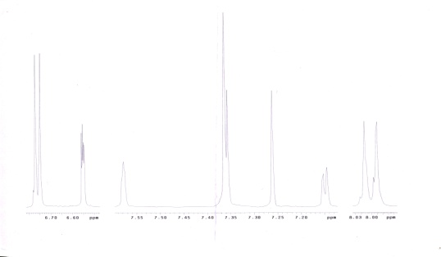
Analysis of ¹³C spectrum
The ¹³C spectrum of 2 is displayed in plate 2A. The signal at 100.8 ppm is assigned to C-5. The signal observed at 163.4 ppm is assigned to C-2. The signals at 156.5 and 166.0 ppm are due to C-6 and C-4 carbons. The signal observed at 124.7 ppm is due to phenyl quaternary carbon attached to the pyrimidine ring. The methyl carbon of the dimethylamino group resonates at 40.4 ppm. The signal observed at 152.8 ppm is due to furanyl quaternary carbon attached to the pyrimidine ring. The signals observed at 144.4, 112.3 and 111.1 ppm are assigned to C-a, C-b and C-c carbons of furan ring. The signals observed at 128.5,111.9 and 152.3 ppm are assigned to C-a’ , C-b’ and C-c’ carbons of the phenyl ring.
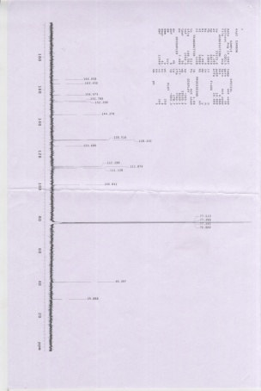
Analysis of FT-IR spectrum
The FT-IR spectrum of 2 is displayed in plate 2A. The absorption at 3326.8 and 3185.5 cm⁻¹ are due to N-H asymmetric and symmetric stretching vibrations respectively of the primary amino group. The weak absorption at 2920.0 cm⁻¹ is assigned to aromatic C-H stretching vibration. The band at 1601.1 cm⁻¹ indicates N-H in-plane bending vibrations of the primary amino group. The absorption band at 1241.8 cm⁻¹ is consistent with C-N stretching vibration. The C-H out-of-plane bending vibration in 2-substituted furan is observed at 809.6 cm⁻¹.

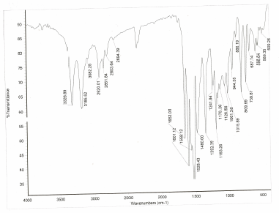

2-Amino-6-[3,4-(dimethoxy)phenyl]-4-(furan-2yl)pyrimidine (3A)
Analysis of ¹H NMR spectrum
The ¹H NMR spectrum of 3 is given in plate 3A. The singlet for two protons at 5.28 ppm is assigned to the amino protons. The singlet for the H-5 proton is observed at 7.26 ppm. The aromatic protons resonate in the region of 6.50-7.69 ppm. The two singlets observed at 3.9 and 4.0 ppm are due to methoxy protons.
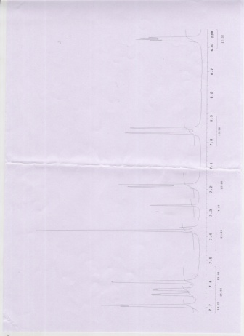
Analysis of ¹³C spectrum
The ¹³C spectrum of 3 is displayed in plate 3A. The signal at 101.5 ppm is assigned to C-5. The signal observed at 163.5 ppm is assigned to C-2. The signal at 156.9 and 165.7 ppm are due to C-6 and C-4 carbons. The signal observed at 130.3 ppm is due to phenyl quaternary carbon attached to the pyrimidine ring. The signal observed at 152.4 ppm is due to furanyl quaternary carbon attached to the pyrimidine ring. The signals observed at 144.6, 112.4 and 109.9 ppm are assigned to C-a, C-b and C-c carbons of furan ring. The signals observed at 110.9, 151.4, 149.3,111.5 and 120.4 ppm are assigned to C-a’, C-b’, C-c’, C-d’ and C-e’ carbons of the phenyl ring. The signal observed at 56.1 is due to the methoxy carbon.
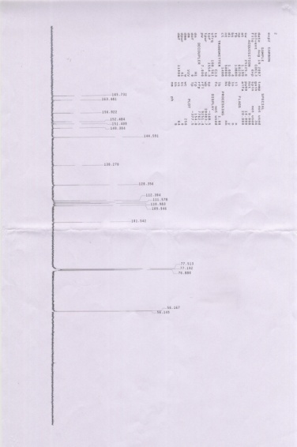
Analysis of FT-IR spectrum
The FT-IR spectrum of 3 is displayed in plate 3A. The absorption at 3317.3 and 3182.5 cm⁻¹ are due to N-H asymmetric and symmetric stretching vibrations respectively of the primary amino group. The weak absorption at 2960.5 cm⁻¹ is assigned to aromatic C-H stretching vibration. The band at 1648.5 cm⁻¹ indicates N-H in-plane bending vibrations of the primary amino group. The absorption band at 1216.7 cm⁻¹ is consistent with C-N stretching vibration. The C-H out-of-plane bending vibration in 2-substituted furan is observed at 826.1 cm⁻¹.

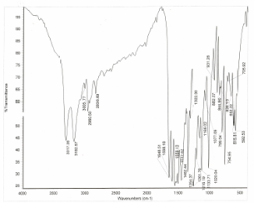

EXPERIMENTAL
Preparation of Compounds
General procedure for preparation of 3-aryl-1-furan-2ylprop-2-en-1-one’s (1-3)
A mixture of appropriate benzaldehyde (0.01 mole), 2-furyl methyl ketone (0.01mole) and sodium hydroxide pellets (0.05 mole) was finely powered in a pestle and mortar. The mixture was transferred into a 100 ml beaker and irradiated in the domestic microwave oven (LG Grill,MG 395WA). The mixture was irradiated at 320W for 30–40 seconds. Then, distilled water was added, the separated solid was collected in a Buckner – Funnel filtered and dried. The compound was recrystal with suitable solvent. The following compounds were prepared by adopting the above general method.
- 1-(furan-2yl)-3-(4-methoxyphenyl)prop-2-en-1-one (1)
- 3-[4-(dimethylamino)phenyl]-1-(furan-2yl)prop-2-en-1-one (2)
- 3-[3,4-(dimethoxy)phenyl]-1-(furan-2yl)prop-2-en-1-one (3)

The molecular formula, melting point and yield are given in Table- 1

Table -1. The melting point and yield of 1, 2 and 3
Compound | Melting point(°C) | Yield %
1 | 220 – 222 | 72.5
2 | 230 – 232 | 69.3
3 | 189 - 190 | 75.0
The formed 3-aryl-1-(furan-2yl) prop-2-en-1-ones were confirmed through FT - IR spectra. The FT - IR spectrum of 1, 2 and 3 are displayed in plates 1A, 2A and 3A. The FT - IR spectral data are given in Table- 2

Table – 2. The FT - IR spectral data of 1A, 2A and 3A.
Compound | Absorption frequency(cm⁻¹) | Mode of vibration
1 | 1657.7  1610.8  982.1  831.8 | C=O stretching  C=C stretching  C-H out-of-plane bending in –CH=CH-  C-H out-of plane bending in 1,4-disubstituted benzene ring
2 | 1663.6  1593.5  918.9  806.4 | C=O stretching  C=C stretching  C-H out-of-plane bending in –CH=CH-  C-H out-of plane bending in 1,4-disubstituted benzene ring
3 | 1663.9  1592.7  1024.5  810.8 | C=O stretching  C=C stretching  C-H out-of-plane bending in –CH=CH-  C-H out-of plane bending in 1,4-disubstituted benzene ring

Preparation of 2-amino-6-aryl-4-(2-furanyl)pyrimidines
A mixture of 3-aryl-1-furan-2ylprop-2-en-1-one (0.01 mole), guanidine hydrochloride (0.01 mole) and sodium hydroxide pellets (0.05 mole) was finely powered in a pestle and mortar. The mixture was transferred into a beaker and irradiated in the domestic microwave oven (LG Grill, MG395 WA). The mixture was irradiated at 320 W for 60-80 seconds. Then, distilled water was added to remove the excess of alkali and then filtered and dried. The product was separated from the reaction mixture by column chromatography using benzene and ethyl acetate mixture as eluting solvent. The following 2-aminopyrimidines were prepared by adopting the above general procedure.
- 2-Amino-6-(4-methoxyphenyl)-4-(furan-2yl)pyrimidine (1A)
- 2-Amino-6-[4-(dimethylamino)phenyl]-4-(furan-2yl)pyrimidine (2A)
- 2-Amino-6-[3,4-(dimethoxy)phenyl]-4-furan-2ylpyrimidine (3A)
Table – 3.The irradiation time, yield and melting point of 1A, 2A and 3A
Compound | Microwave irradiation Time(sec) 320W | Microwave irradiation  Yield % | Melting point (ºC)
1A | 77 | 69.9 | 215-216
2A | 65 | 80.5 | 187-188
3A | 79 | 78.4 | 156-158

Spectral measurements
¹H NMR spectra
Proton NMR spectra were recorded on BRUCKER AMX – 400 MHz or BRUCKER 200 MHz Spectrometer. Samples were prepared by dissolving about 10 mg of material in 0.5 ml of CDCl₃ containing 1% TMS. All the chemical shifts are referenced to TMS.
¹³C NMR spectra
The ¹³C spectra were recorded on a BRUCKER 200 MHz spectrometer. Sample were prepared by dissolving 50 mg of the compound in 0.5 ml of CDCl₃ containing 1% TMS. All the chemical shifts are referenced to TMS.
FT-IR spectra
The FT-IR spectra were recorded on NICOLET AVATAR 330 FT-IR instrument in KBr pellets.
CONCLUSION:
Microwave assisted synthesis of 2-Aminopyrimidine has advantages due to reduced reaction time, solvent-free condition and high yield. H-NMR spectrum shows a signal in the range of 5.1-5.3 ppm and IR spectrum show bands in the range 3456-3182 cm⁻¹ due to the free amino group of compounds 1A -3A.

REFERENCE:
- Byers, T.; Anda R.; McQueen, D.; Williamson, D.; Mokdad, A.; Casper, M.; Ford E. and Marks, J. (1998). 1991±1992. Preventive Medicine (1998) 27, 311 -316.
- Diaz, M. N.; Frei, B.; Vita, J. A. and Keaney, J. F. New England Journal of Medicine (1997) 337, 408 - 416.
- Lifshitz, F. Journal of the American College of Nutrition (1997) 16, 507- 509.
- Adamson, R. H.; Gustafsson, J. A.; Ito N.; Nagao M.; Sugimura T.; Wakabayshi, K. and Yamazoe Yeds. Princeton Scienti®c Publishing, Princeton, NJ. (1995)
- Weisburger, J. H. and Williams, G. Causes of cancer. In American Cancer Society Textbook on Clinical Oncology, ed. G. Murphy, W. Lawrence and R. E. Lenhard, pp. 10 -39. American Cancer Society, Atlanta, GA. (1995).
- Wynder, E. L. and Hoffmann, D. Cancer Research (1994) 54, 5284 -5295.
- Ishikawa, T.; Suzukawa, M.; Ito T.; Yoshida, H.; Ayaori, M.; Nishiwaki, M.; Yonemura, A.; Hara, Y. and Nakamura, H. American Journal of Clinical Nutrition (1997) 66, 261 -266.
- Knekt, P.; Jarvinen, R.; Reunanen, A. and Maatela, J. British Medical Journal (1996) 312, 478±481.
- Kasai, H. and Nishimura, S. Nucleic Acids Research (1984) 12, 2137-2145.
- Poulsen, H. E.; Prieme, H. and Loft S. European Journal of Cancer Prevention (1998) 7, 9-16.
- Fujiki, H.; Suganuma, M.; Okabe, S.; Komori, A.; Sueoka, E.; Sueoka, N.; Kozu, T. and Sakai, Y. Nutrition Reviews (1996) 54, 67-70.
- Lu, Y-P.; Lou, Y-R.; Xie, J-G.; Yen, P.; Huang, M.-T. and Conney, A. H. Carcinogenesis (1997) 18, 2163-2169.
- Nakachi, K.; Suemasu, K.; Suga, K.; Takeo, T.; Imai, K. and Higashi, Y. Japanese Journal of Cancer Research (1998) 89, 254-261.
- Okunevich, I.O.; Sapronov, N.S.; Ryzhenkov, V.E.; Khim.-Farm. Zh., (1999) 33(12), 25 – 27.
- Ahluwalia, V.K.; Aggarwal, R.; Bala, S. and Chandra, R. Indian J. Chem., (1989). 28(8), 964.
- Ahluwalia V.K.; Chauhan, A. and Khurana, A. Indian J. Chem., (1991) 38(B), 1062.

