Effect of Fibers on Properties of Concrete

Milind R. Nikhar
Assistant Professor
Civil Engineering Department,
B.D.C.E, Sevagram, Wardha, India
Email: - milind.nikhar@gmail.com

Prof. R. G. Bais
Guide
Civil Engineering Department,
B.D.C.E, Sevagram, Wardha, India
Email: - rgbais@rediffmail.com

Abstract: In this project the effect of fibers on different properties like compressive strength and flexural strength of concrete also the effects of fibers on plastering is studied. The available different types of fibers are added to the normal concrete considering various proportions with respect to cement.
Test results were obtained by carrying tests such as compression, tensile and flexural tests. From these results the feasibility of types of fibers is suggested.
Keywords: Natural Fibers, Man-made fibers, compressive strength, tensile strength, flexural strength.

- Introduction
From the time when the introduction of fiber reinforcing of concrete in the 1940's, a huge arrangement of testing has been carried on the various stringy materials for determining the definite uniqueness and return for each product. This piece of writing will look at some of these fibers, their application and some harm.
Portland cement concrete is measured to be a fairly breakable material. When subjected to tensile stressed out, unreinforced concrete will break and fall short. From the time when the middle 1800's steel reinforcing has been used to defeat this difficulty. As a compound system, the reinforcing steel is understood to carry all tensile loads. When fiber reinforcing is supplementary to the concrete blend, it also can add to the tensile loading capability of the compound system. In fact, study has shown that the ultimate strength of concrete can be amplified as much as 5 times by addition of fiber reinforcement.
Reinforcing fibers will widen more than concrete in loading. Therefore, the compound structure of fiber reinforced concrete is understood to work as if it would be unreinforced awaiting it reaches its "first crack strength." Hence from this point of practical, that the fiber reinforcing takes more than and holds the concrete as one.
On behalf of fibers reinforcing, the highest load carrying capacity is restricted by fibers pulling out of the compound because fiber reinforcing does not show a distorted surface like larger steel reinforcing bars shows. This condition restricts presentation to a point far less than the yield strength of the fiber itself. This is significant since some fibers are more "slippery" than others when used as underpinning and will affect the toughness of the concrete item for consumption in which they are placed.
Toughness is based on the whole energy wrapped up prior to face up failure.
The main belongings manipulate toughness and highest loading of fiber reinforced concrete are;
- Fiber types used.
- Volume of fiber.
- Aspect ratio (the length of a fiber divided by its diameter).
- Direction of the fibers in the matrix.
Resources used in fiber reinforcing are together with acrylic, asbestos, cotton, glass particles, nylon particles, polyester substances, polyethylene stuffs, polypropylene stuffs, rayon, rock wool and steel. Among these, materials, anti acid glass and steel fibers have recognized the most alertness. Plastic fibers have shown to be of little value in reinforcing concrete. Natural fibers are subject to alkali attack and are also determined to have minute worth. Nylon is at present making an appearance in slab-on-grade skill.
Fiber percent in the concrete mix together is based on amount and is uttered as a percent of the blend. Tests varying from 1.7% to 2.7% are ordinary. While volumes larger than 2% are used, the concrete can be not easy to mix. When concrete is placed by procedure other than a ready mix truck, the fiber volume may be higher. One such example is when shot concrete was used volume of 2.3% have been fruitfully used. In some pre-casting operations with fiber reinforced concrete amount percentages have been taken as high as 5%. Normally, if all other properties are the same, concrete strength increases linearly among volume of fiber.
Aspect ratio is only the measurement lengthwise of a fiber divided by its diameter. This property is used to correspond to the amount of surface area of the fiber adjacent to the concrete mix. It has been found that bundling of fibers in the mix increases as the aspect ratio increases. 100 the aspect ratio for steel fibers was set up to be most favorable.
Direction of the fibers is usually unsystematic, simply because they are not positioned one at a time in a straight line. Fibers are also added to the dry cement or sprayed on a form and enclosed with the wet concrete mix. Both of these measures will manufacture a casual pattern of fiber reinforcing. On the other hand, tests with steel fibers have exposed that they can be allied by using magnets and that the resultant concrete will have an enhanced final strength. This process is used in fabricating precast beams and columns.
From the time when the 1940's many functions for fiber reinforced concrete have been exposed and nearly every one of them have used either steel fibers or glass fibers. Steel fibers have originated their position in paving, rock stabilization. Placing technique contains straight pouring from a ready mix truck, while in road work and airport runways, and shot-creating for other civil construction projects, together with water runoff and spillways and steep slope control.

- Definition of Fiber Reinforced Concrete:
Plain cement concrete is measured to be a brittle material because of its low tensile strength and impact resistance. Now it has been well-known that by adding up of small diameter, short length, and randomly spread fibers it is likely to bring in relation to marked improvements in the tensile strength and impact resistance properties of concrete. Concrete with fiber is termed as fiber reinforced concrete. The improvements in the properties depends upon various factors like material of fiber, their shape, size, pattern of distribution and magnitude in the concrete mix.
In other words Fiber reinforced concrete is a mixture of Conventional Concrete (cement, water, rock and sand) + Fibers.
Fibers can be ready available in many unlike material types:
• Steel
• Synthetic - polypropylene, nylon, carbon, polyester, aramid, etc.
• Natural (cellulose)
• Glass (alkali resistant)

- Difference Between Conventional Reinforcement and Fiber System:
- Fibers are normally spread all the way through a specified cross section whereas reinforcing bars or wires are placed only where compulsory.
- Mostly fibers are moderately short and very much spaced as compared with continuous reinforcing bars or wires.
- It is generally not likely to get the same area of reinforcement to area of concrete using fibers as compared to using a system of reinforcing bars or wires.
- Fibers are characteristically added to concrete in low volume quantity (often less than 1%), and have been given away to be effective in dropping plastic shrinkage cracking.
- Fibers classically do not significantly modify free shrinkage of concrete, on the other hand at high adequate dosages they can increase the resistance to cracking and decrease crack width (Shah, Weiss, and Yang 1998).

- Need for the use of Fiber Reinforced Concrete:
- Disadvantages of Steel Reinforcement:
For slender concrete beams under flexural loading it is assumed that the strains vary linearly over the depth with compressive strains in the top and tensile strains in the bottom of the beam. Tensile strength of concrete is weak and is ignored when determining the final load carrying capacity. As a result the main load carrying elements of the beam consist of the concrete compression zone (approximately 20-25% of the cross section) and the steel reinforcement is lowered.
The two main disadvantages of reinforced concrete beams are the probable deterioration of the reinforcement and the very much self weight. The concluding in particular is an imperative issue given the fact that 75-80% of the material that contributes to the weight (concrete in the tensile zone) does not directly contribute to the overall load carrying capacity. The low cost of concrete is probably the main reason that this has not been a major issue in the past.

- Improvements due to Addition of Fibers:
FRP materials can be used to improve this traditional concept in a quantity of areas. Consider, substitute of the steel reinforcement with FRP reinforcement eliminates the corrosion trouble. However, this replacement directs towards the corrosion issue only, and does not provide any significant reduction in the self weight. With the steel reinforcement replaced by FRP reinforcement, the main purpose of the fractured concrete is to locate the tensile elements relative to the compression region. Showing a number of entity reinforcement bars is considerably more difficult than locating a single tensile flange. Hence, substitution of the FRP bars with a continuous FRP tensile flange is a logical next step. A single or double web steel beams cross sections are commonly provided as continuous tensile flange. By placing the fibers in the web members at +45o and -45 o the webs are preferably appropriate to bear the shear forces in the beam thereby eliminating the need for shear rings. On the other hand, the cracked concrete not only located the reinforcement relative to the compression region, it as well enables the compression region to carry localized loads. In order to reinstate this ability, extra FRP reinforcement is positioned in the concrete compression flange. Combined exploit between the concrete and the FRP reinforcement can be obtained through use of a high class epoxy adhesive.

- Role of Fiber Size
To bridge the large number of micro cracks in the composite under load and to avoid large strain localization it is necessary to have a large number of small fibers. The standardized allocation of short fibers can increase the strength and ductility of the composite.
Long fibers are needed to bridge discrete macro cracks at higher loads; however the volume fraction of long fibers can be much smaller than the volume fraction of short fibers. The being there of long fibers appreciably reduces the workability of the mix.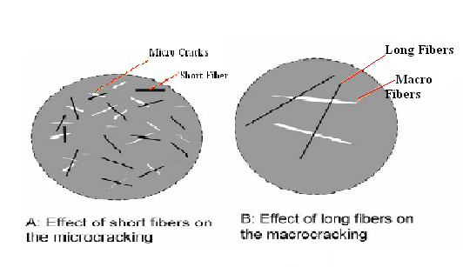
- Types of fiber used in this project:-
  - Lath machine waste
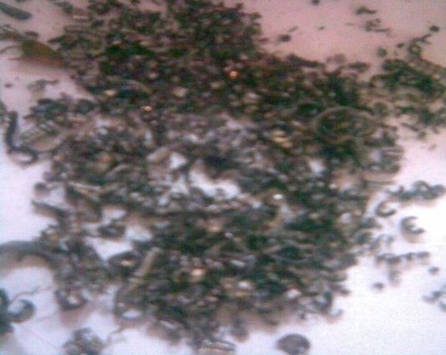

  - Recron 3s synthetic fibre

  - Shaktiman steel fibre
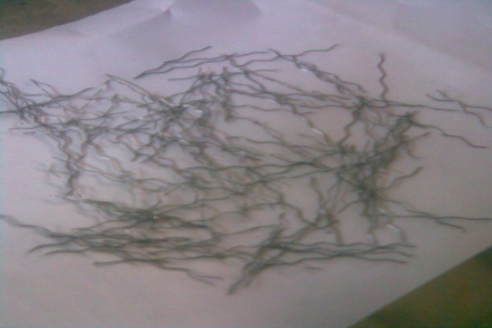
  - Human hair (only for plastering)

- Result and Review
  - Lath Machine Waste
- 7 Days Compressive Strength
- Compressive Strength (28 days)

- Flexural Strength (28 Days)

  - Shaktiman Steel Fibres
- 7 Days Compressive Strength
- Compressive Strength (28 Days)

- Flexural Strength (28 Days)

  - Human hair (only for plastering)

- The Plaster made by using Recron 3s fiber has very smooth surface
- While in plaster using human hair, the hair bundled in mortar and they come out of surface after plastering.

- Conclusion
From above results it is observed that by adding up of percentage fibers the strengths like compressive, tensile and flexural is kept rising after increasing the percentage of fibers, whether it is for lath machine waste or “Shaktimaan” steel fibers. Also the following conclusions are drafted.
- Fiber Reinforced Concrete will play a major role in the of civil engineering structures in the 21st century.
- The high strength to weight percentage as well as non corrosive uniqueness of these resources could be utilized to construct pioneering structures that cannot be built using the present conformist resources.
- FRC could be used to build light, yet more durable and economic structures. Designers should be encouraged to utilize these materials based on its unique characteristics rather than a replacement for the current conventional materials.
- The fiber reinforced concrete have high initial investment during construction because of which it is not possible to use this concrete in each and every part of a country.
- Fiber reinforced concrete is design for reasonably high worth of strength. The winning piece of a fiber reinforced concrete very much depends on ensuring that the design requirements are met by the fiber reinforced concrete as constructed.

- References:
Jeffery R. Roesler, Salah A. Altoubat, January-February 2006, “Effect of Synthetic Fibers on Structural Behavior of Concrete Slabs-on-Ground” ACI Materials Journal, Title no. 103-M01.
Youjiang Wang, Stanley Backer, “An Experimental Study of Synthetic Fiber Reinforced Cementitious Composites”, Journal of Material Science 22,- pp.4281-4291.
A.L.Ardeshana, Dr. Atul K Desai, July-August 2012, “Durability of Fiber Reinforced Concrete of Marine Structures”, International Journal of Engineering Research and Applications, pp.215-219.
R.Gowri, M.Angeline Mary, July 2013, “Effect of glass wool fibres on mechanical properties of concrete”, International Journal of Engineering Trends and Technology (IJETT) - Volume4 Issue7, pp. 3045-3048.
G.Murali, C.M.Vivek Vardhan, Mar-Apr 2012, “Experimental Investigation on Fibre Reinforced Concrete Using Waste Materials”, International Journal of Engineering Research and Applications, pp.278-283.
R. Kandasamy and R. Murugesan, March 2011, “Fibre Reinforced Concrete Using Domestic Waste Plastics as Fibres”, ARPN Journal of Engineering and Applied Sciences, Vol. 6, No. 3, pp. 75-82.
Amir M. Alani, Morteza Aboutalebi, 2013, “Mechanical Properties of Fibre Reinforced Concrete - A Comparative Experimental Study”, International Journal of Civil, Architectural Science and Engineering Vol:7 No:9, pp. 37-42.
Rashid Hameed, Anaclet Turatsinze, July 2009, “Metallic Fiber Reinforced Concrete: Effect of Fiber Aspect Ratio on the Flexural Properties”, ARPN Journal of Engineering and Applied Sciences, Vol. 4, No. 5, pp.67-72.
Concrete Technology- M.S. Shetty- Chapter: 2- “Types of Cement and Testing of Cement”-pp.-43.
Chapter 10- “Testing Of Hardened Concrete”-pp.-366-376.
Building Construction- Sushil Kumar- Chapter 20- “Plastering, Painting, & White Washing-Clause 20.1-Plaster”-Pp.-483 to-485.
Journal of Structure Engg. - Vol .129 –“Effect Of Strength and Fiber Reinforcement on Fire Resistance of High-Strength Concrete”-pp. 253.
I.S.516-1959- Methods of Tests for Strength of Concrete—Compression Strength- Clause no. 3 & 5.
I.S.516-1959- Methods of Tests for Strength of Concrete—Flexural Strength Clause no. 7 & 8.
I.S.-4031-1988- Methods of Physical Tests for Hydraulic Cement (Part IV) -Compression Strength of Cement- Clause no. 6, 7, & 8.
I.S.-650-1991- Standard Sand For Testing Cement Specification.

