Design and Development of Greenhouse Hybrid Tri-generation System Using Solar Energy and Kitchen Food Waste

Sudarshan L. Chavan Rohan S. Kulkarni Dr. Dhananjay B. Talange
Dept. of Electrical Engg. Dept. of Electrical Engg. Dept. of Electrical Engg.
Rajarshi Shahu College Engg.,Pune. Vishwakarma Institute of IT,Pune. Govt. College of Engg.,Pune.
S. F. Pune University(INDIA). S. F. Pune University(INDIA). S. F. Pune University(INDIA).
chavan_sl@rediffmail.com rohaneln@gmail.com talanged@gmail.com

Abstract
The progressive decrease of fossil fuels and the increase of environmental problems associated to their combustion, force to the searching of new energy alternatives. Grid independent electric power system using renewable power sources such as solar and biomass can potentially and drastically reduce CO₂ emission while offering citing flexibility and economic advantages. Countrywide concerns of resource scarcity and climate change are driving the search for carbon-neutral, renewable energy alternatives for fossil fuels. Disposal of organic wastes such as kitchen waste from homes, hotels and canteens is a biggest problem in urban areas. Recognizing the potential embedded in solar energy and different types of organic waste, various energy conversion technologies have been developed. The present research work focuses on the feasibility of generating electricity, heat and hydrogen(Tri-Generation) using bio-energy from food waste, and solar energy.

Key words: Tri-Generation, Anaerobic Digester, solar PV/Thermal systems, Fuel Cell, Smart Controller.

I. INTRODUCTION
With the continuous depletion of fossil energy and increasing environmental concerns, developing renewable energy sources becomes more and more important. Today, fossil fuels still dominate the energy market, accounting for 87% of total global energy consumption[3]. The progressive decrease of fossil fuels and the increase of environmental problems associated to their combustion, force to the searching of new energy alternatives. Solar energy and biomass energy are two important sustainable energy sources. Therefore, production of electricity to power our world from solar energy and biomass can reduce the dependence on fossil fuels. Disposal of organic wastes such as kitchen waste from homes, hotels and canteens is a biggest problem in urban areas. Anaerobic digestion is the most promising alternative to disposal this kind of waste, due to high energy recovery. The Kitchen waste can be converted into biogas using anaerobic digestion process. The main objective of anaerobic digestion is the degradation and destruction of organic substances, with consequent reduction of the odorous emissions and pathogens. Anaerobic digestion (AD) is a process by which microorganisms break down biodegradable material in the absence of oxygen to produce biogas which is great source of Hydrogen. The generated Biogas can be processed in fuel cell system to generate electricity and hydrogen. Solar energy is another sustainable energy source which has potential to produce both electricity and heat. In proposed solar PV/Thermal systems, solar thermal collectors are combined with PV cells, to form hybrid energy generating units that simultaneously produce the two types of energy, required by most consumers, low temperature-heat and electricity. The solar radiation that are absorbed from the sun are converted to electricity partially by the PV cells and partly of the excess heat generated in them is transferred to the heat exchanger in thermal contact with the PV cells while the rest is lost to the ambient. The block diagram of proposed system is shown in fig.1.The proposed Tri-generation system which generates Electricity, Heat and Hydrogen simultaneously consists of following main parts.

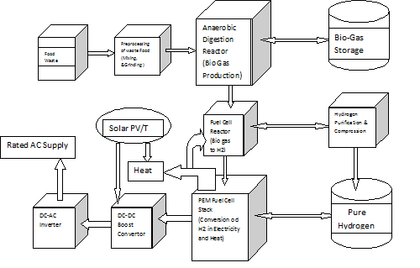
Fig.1 Block diagram of proposed system.

- Anaerobic Digester reactor
- Fuel Cell system
- Solar PV/Thermal system
- Hydrogen purification and storage system.
- Mechanical system for hydrogen purification and storage.
- Smart controller to produce stable electrical power.

II. ANAEROBIC DIGESTION REACTOR
The kitchen waste or food waste collected from various homes, canteens and hotels is considered to a feedstock for anaerobic digestion reactor. Anaerobic digestion (AD) is a microbial decomposition of organic matter into methane, carbon dioxide, inorganic nutrients and compost in oxygen free environment [5].
Generally three main reactions are taking place during the entire process of the anaerobic digestion to methane: hydrolysis, acid forming and methanogenesis. Although AD can be considered to take place in three stages all reactions occur simultaneously and are occurring interdependently[19]. The process of anaerobic digestion is shown in fig.2
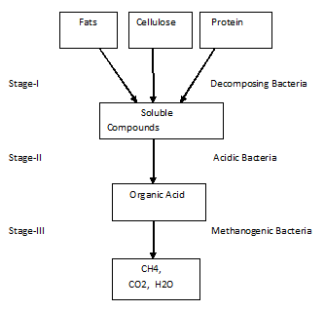
Fig.2 Anaerobic digestion process
The first aim of the proposed research is the design and development of optimized, cost effective Anaerobic Digestion Rector to produce Methane or Biogas from Kitchen Waste. To fulfill the aim it is require to identify the best available AD technology by analysis of the number of existing plants, their operating capacities, process efficiency, feedstock flexibility, and the experience of plant operators of the foremost technologies. On the basis of the above information, it is required to find the challenges and problems associated with the application of AD technology as part of the Kitchen waste management systems.
Classification of the AD systems
Presently there are different technologies available in the market for AD treatment of the organic fraction. These systems differ based on the design of the reactor and the operating parameters[19]. The design of the reactor depends on the feedstock which is required to be processed and varies from very simple and easy to maintain AD digesters used in rural areas in India to very complex and automatic systems used lately in the developed countries for treatment of the organic fraction. As bigger systems have been proven to be reliable and economic, so the trend is to build bigger plants. The AD technologies used presently are Kompogas, Valorga, RosRoca, BTA,Dranco, Cites and Linde [4]. The total installed capacity worldwide today of each of these technologies is shown in table 1.

Table1
AD  technology | No. of  plants | Total capacity,  tons/year
Kompogas | 26 | 533,500
Valorga | 19 | 2,197,000
Ros Roca | 17 | 541,000
BTA | 17 | 300,500
DRANCO | 15 | 627,000
Citec | 13 | 469,500
Linde | 11 | 459,000
The retention time, biogas production rate and total annual biogas production of various AD technologies are shown in table 2 [1].
Table 2.
AD  technology | Retention time,  (days) | Biogas production  (Nm3/Mg of feed) | Total annual biogas  production (Nm3)
Kompogas | 15-20 | 100 | 53,350,000
Valorga | 18-25 | 80-160 | 263,640,000
BTA | 12 -17 | 85-95 | 27,045,000
Dranco | 20 | 100-200 | 94,050,000
The previous research work shows that the best available AD technology is the Valorga high-solid content process. This technology points high flexibility in term of feedstock quality and high efficiency in biogas production per ton of processed waste food and therefore proposed for this research work[8]. Grinding and proper mixing of feedstock is required as a pretreatment before it is entering in AD reactor. After the pretreatment the waste is mixed into a thick sludge(TS) with concentration of 25- 32 % of TS and introduced in the AD reactor from the bottom. The Valorga reactor is a vertical, plug-flow cylinder separated into two compartments by a vertical partition. This wall extends 2/3 of the diameter and in full height of the reactor. The design of the reactor ensures that the material moves up and around the partition. The generated biogas is re-circulated from the bottom of the reactor to provide mixing and suspension of the solids as the slurry moves through the reactor. The proposed Valorga process is operated at high solids concentration (25-32%), and can be operated on both mesophilic (25-40 °C ) and thermophilic (50- 65 °C) operating temperature[7]. The water from digested material is removed and the solid material is treated aerobically to completely stabilized compost. The biogas produced in this reactor is either stored in storage tank or used in fuel cell reactor to produce hydrogen.

III. SOLAR PV/THERMAL SYSTEM
As there is rapid growing demand for solar thermal and photovoltaic (PV) electricity generation, there are lot of ideas coming up with the aim for a wide range of application including agriculture, processing plant and buildings. The solar PV/Thermal (PV/T) consists of module in which PV module is combined with solar thermal collector forming one device that converts solar radiation into heat and electricity simultaneously[14]. It is observed that, solar energy absorbed by the solar cell (PV Cell) is not completely converted into electricity, it also produces heat and decreases the electricity efficiency. The effect of heat on solar panel’s output shown in figure 3.
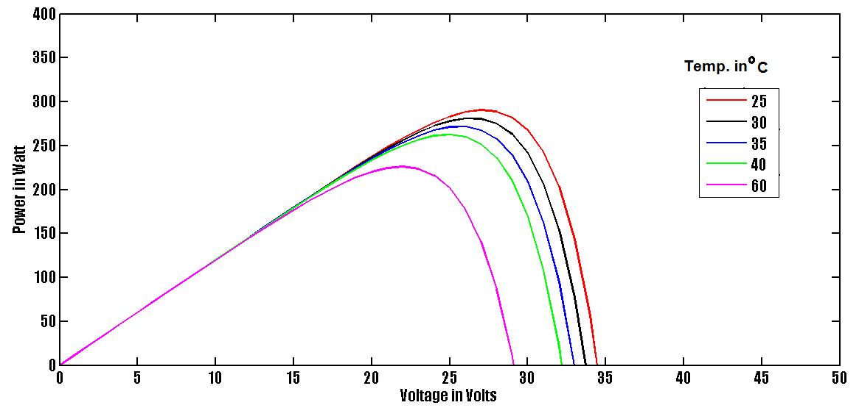
Fig.3 Effect of temperature on Si- solar panel output power
It is reported that the efficiency of a PV solar cell decreases with an increase in the operating temperature and cooling them is necessary. It is necessary to extract produced heat from panel and utilize that heat energy for other applications like water heating, this combined system known as Solar PV/Thermal (PV/T) system[14]. Solar PV panel cooling can be done by circulating a ﬂuid on its rear surface. In the poposed solar PV/Thermal systems, solar thermal collectors are combined with PV cells, to form hybrid energy, generating units that simultaneously produce the two types of energy, required by most consumers, low temperature-heat and electricity. The sun’s total energy contains 7% ultraviolet radiation, 47% visible radiation and 46% infrared (heat) radiation The solar radiation that are absorbed from the sun are converted to electricity partially by the PV cells and partly of the excess heat generated in them is transferred to the heat exchanger in thermal contact with the PV cells while the rest is lost to the ambient. Some previous research work pointed extracting heat from panel using fluid flow method, but heat extraction is not up to the mark in such systems[9]. When there is rise in temperature of panels, there is a drastic reduction is observed in the efficiency of PV panel. The Infrared (IR) radiations of sun are responsible for production of heat in solar cells. It is proposed to design Smart material thin film coating which is hydrophobic in nature. This coating will reflect IR waves and passes only visible and fraction of ultraviolet radiations, which result in reduction of operating temperature of PV panel and improves electrical efficiency of panel. The reflected IR waves will be collected as heat energy and can be utilized for water heating process.
A parabolic shaped collector is proposed for the implementation of solar PV/T system. To improve the efficiency further, a steeper motor based on solar tracking system is proposed. This solar PV/T system will provide efficient electrical energy as well as moderate amount of heat energy. To extract heat from solar cell it is required to should know how heat get generated in cell. The solar spectrum consists of 3 primary radiation: the ultraviolet (UV), visible light and the infrared, shown in Figure 4.
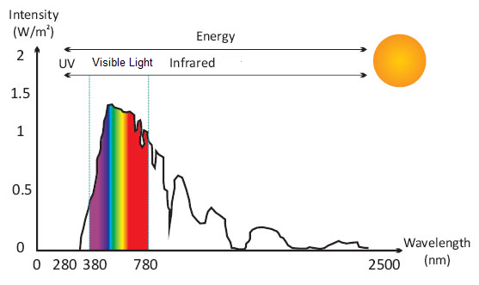
Fig.4 Solar spectrum
The heat from the solar spectrum generated primarily by the Infrared (IR) wave. IR radiations absorbed by the solar cell produces vibration at atomic level, these vibrations (also known as phonons) are responsible for heat production. IR radiations can be filtered out using thin film coating on panel glass[12]. For this purpose, a thin film optical coating approach is proposed to reflect IR wave from solar panel glass and collect this heat energy for utilization. This method of heat collection is efficient as compare to other PV/T system (which uses fluid flow) because of less heat losses.
Optical Coatings:
The purpose of coating on solar panel glass is to modify reflection and transmission properties of glass surface. Previous research work points Anti Reflecting (AR) coating to reduce reflection losses and to trap light inside panel to improve its efficiency [12]. The design of any AR coating can be characterized by the irradiance, emittance and absorptance of the sources and media in which the AR will operate. It can also be characterized by the optical properties, index of refraction and extinction coefficient, of the coating materials and substrates used in the optical system. The spectral band over which the coating must operate defines the anti-reflection problem. For PV solar cells implies the solar spectra. AR coating passes IR light through it, which results in rise in temperature on solar cell and reduces electrical efficiency which is main problem.
The IR reflector coating can be designed for different applications like in digital camera lens. It is also used to protect systems from IR radiation like optical fiber. A typical characteristics of IR reflector glass is shown in figure 5.
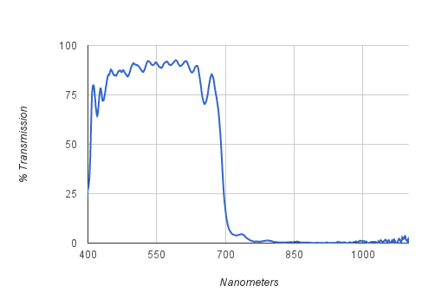
Fig.5 Characteristics of IR reflector
It is possible to design thin film coating which will reflect heat producing wavelength and only pass visible wavelength. Type of material of thin film and thickness of film decides transmittance and reflectance for particular band of wavelength. The required optical property shown in figure 6.
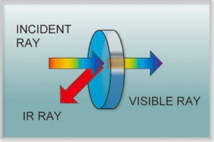
Fig.6 IR reflector glass
This will help to reduce panel temperature and improve its efficiency. The reflected IR radiation is nothing but heat energy, it is possible to collect these radiation and utilize heat for other processes like water heating.

Hydrophobic Property:
The output of solar panels decreases due to dust on panels, reducing its efficiency every day. It is proposed to design Smart material optical coating which are hydrophobic in nature, so that this coating will not allow dust particle to settle on its surface. This will help to improve electrical output efficiency of solar panel.
Modeling of parabolic structure:
Solar concentrators make use of basic geometric definitions in order to direct rays into a focus. The parabolic structure is utilized due to its ability to reflect all rays parallel to its axis into a central focus. Elongated parabolic troughs and parabolic dishes are two technology that utilize this geometry. Parabolic solar system must compensate the changing angle of incident rays of sun throughout a day to maximize its output efficiency. Modeling of precise parabolic structure is the crucial part of this research work. Proposed system diagram shown in figure7. In the inner part of parabola, solar cells with smart material coating placed. The reflected light rays shown in figure will be IR waves.A microcontroller based steeper motor solar tracking system for complete structure will help to improve efficiency of the panel. The electricity generated by the Solar PV/T is used to heat water which is flowing through collector pipe.
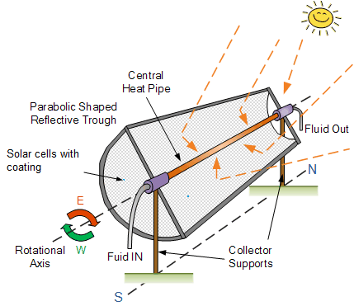
Fig7. Proposed parabolic PV/T system
IV. FUEL CELL SYSTEM
The fuel cell system consist of fuel cell reactor and fuel cell or fuel cell stack.
Fuel cell Reactor
The function of the fuel cell reactor to convert Methane or Biogas to hydrogen which can be used in fuel cell to generate electricity. The biogas produced by AD reactor has great potential for H2 generation. The hydrogen from the biogas can be extracted through several reforming processes. However, selecting a specific process depends on several factors, some of which are: biogas composition, purity required for using H2, volume production of the required H2, and investment availability, among others. In most of the reforming technologies, the problem is developing catalysts capable of preventing carbon deposition on the active phase in order to increase its useful life. In the case of Dry Reforming process (DR), the problem is even worse, making process unfeasible due to the rapid deactivation of the catalyst. In Dry Oxidation Reforming(DOR), the periodical passage of O2 flow through the catalyst place helps the gasification of the carbon deposited on the surface, increasing the availability of catalytic active sites and somewhat recovering the activity of the material[13][14[15][19]. It is found that in both reforming cases (DR, DOR) the H2/CO ratio is usually close to 1, which restricts the H2 production potential, requiring a higher CO volume to be separated from the products by the Shift reaction, making it difficult to obtain high purity H2. Also, in the DR biogas, part of the H2 produced reacts with CO2 by the reverse shift reaction producing water and CO, which reduces the production yield of H2. Thus, maximizing the H2 liberated from biogas with the SR process, followed by Shift reactions, found to be a less elegant but more feasible solution, particularly regards to minimizing CO and maximizing H2 production. In this case, the H2/ CO ratio obtained is high (close to 3) and the technology involved better known and well controlled. There are many studies which supports biogas in Steam Reforming (SR), despite the high CO2 content, maintaining a high H2/CO ratio (between 2 and 3).[16][17]. The same can results in Partial Oxidation Reforming(POR) and ATR, where biogas can be used directly without drastically reducing the ratio of H2/CO [13-17]. Therefore, Autothermal Reforming (ATR) found to be an attractive technique for generating H2 from biogas, from the standpoint of H2 yield, as well as for the energy efficiency achieved. Additionally, in ATR the reactor can be stopped and restarted quickly, which whenever the discontinuous supply of biogas and energy intake is considered, directly result in the lowest cost/benefit ratio among all the other reforming processes. It is found that lower the CO2 content in biomethane, the more efficient the CH4 conversion in the desired products, which results into easier to obtain high purity H2. But, it should be noted that in this case the DR and DOR processes are not the most suitable ones as CO2 has to be added to the reactor, which in turn is already removed in the previous step during the biogas purification treatment. Thus, the SR, POR and ATR processes are the most recommended ones.
In any conventional reforming process using biogas as raw material, new catalysts with high catalytic activity at high temperatures must be developed. They should be chemically and thermally stable, preventing carbon deposition on its surface (coke) which consequently slows down the inactivation process. With respect to the frequent treatments required to reactivate the catalyst (inside or outside the catalyst bed), or the need for periodic replacement due to its permanent deactivation, which results in production stops, the costs can be very high. This is a major drawback for large-scale H2 production using the reforming processes. According to the operating temperature of the fuel cells, the production method of H2 can be designed/engineered. For high-temperature operating cells, H2 can be produced by internal reforming of hydrocarbons [13][14][15][19]. (methane or biogas).
Fuel cell and Fuel cell stack
The chemical energy present in hydrogen and other hydrocarbon fuels is significantly more than that found in general battery materials. This point focuses the impetus to develop fuel cells for a variety of applications. Fuel cells are an ideal primary energy conversion device for remote site locations and find application where an assured electrical supply is required for generation, distributed power, remote, and uninterruptible power[18]. The general structure of fuel cell is shown in fig.8
Fig.8 The general structure of fuel cell
Fuel cells convert the chemical energy present in a fed fuel into electrical energy on demand. Fuel cells consist of an anode, where oxidation occurs, a cathode, where reduction occurs, and an electrolyte, where ions carry the current between the electrodes. Fuel cells differ from batteries in that the fuel and oxidant are not contained within the fuel external source. Fuel cells are not electrically recharged, actually, fuel cells operates so long as the fuel is supplied. In most of the fuel cells the fuel of choice is hydrogen gas, with the exhaust being a water. Other fuels and hydrocarbons must be converted to hydrogen for use in a fuel cell. The direct conversion of fuels such as CH3OH and CH4 is possible under certain conditions. Each type of fuel cell has a unique set of processes and reactions to describe its operation.
Fuel cells are generally classified into two types; high temperature fuel cells such as molten carbonate fuel cells (MCFCs) and solid oxide polymer fuel cells (SOFCs), which operate at temperatures above 923 K and low temperature fuel cells such as proton exchange membrane fuel cells (PEMs), alkaline fuel cells (AFCs) and phosphoric acid fuel cells (PAFCs), which operate at temperatures lower than 523 K. Due to higher operating temperatures, MCFCs and SOFCs have a high tolerance for impurities such as CO and CO2 (COx). But, the high temperatures also impose problems in their maintenance and operation and therefore the most of the research work has been directed towards low temperature fuel cells. The low temperature fuel cells suffers only by very low tolerance for impurities such as Cox. PAFCs can tolerate up to 2% CO, PEMs only a few ppm, whereas the AFCs have a stringent (ppm level) CO2 tolerance. The Proton Exchange Membrane Fuel cell(PEMFC) is very popular low temperature fuel cell proposed for this research work. A stack of PEM cells is used to produce rated power output[18].
In a simple PEMFC the electrodes are formed on a thin layer on each side of a proton-conducting polymer membrane, used as electrolyte. For understanding, the electrolyte is composed similarly to plasticized electrolyte in a Li ion cell, where a liquid electrolyte component is immobilized in a polymer matrix. It consists of a solid polymer with a perfluorinated side chain that is terminated with a sulfonic acid group. Hydration of the membrane results into dissociation and salvation of the proton of the acid group. The solvated protons are mobile within the polymer and supports electrolyte conductivity. The membrane used has low permeability to oxygen and hydrogen (crossover) for high coulombic efficiency. In a general structure of typical PEMFC graphite (or metal) plate serves as the plenum for the gas supply and for heat removal. A catalyzed carbon layer is applied to the membrane surface. A thicker gas diffusion layer or porous carbon paper provides gas transport to the reaction zone. The composition and amount of catalyst differ for each electrode. The anode used has a lower catalyst loading than the cathode. The platinum-based catalysts are very sensitive to H2S and CO impurities compared to others so they must be eliminated from the feedstock for long
operation of the cell. Generally the catalyst content of the anode is _0.1 mg/cm2, and that of the cathode is _0.5 mg/cm2 term performance. The proton transport carries water along (water drag) while carrying the current. The water concentration gradient results in back diffusion. However, for cell operation at high current, the anode side of the membrane required to be humidified or it will dehydrate. Also, product water is required to be removed from the cathode side in the air stream to prevent flooding of the active layer. For satisfactory operation, a water content of 30-60% in the membrane is preferred. For higher temperature operation, a polybenzimidazole- based polymer electrolyte may be preferred.
The PEMFC structure has very good mechanical integrity under compression and expansion from differential temperature and pressure variations that occur during operation. This system has minimal materials problems, except for the cost and operation characteristics of the membrane. The PEMFC operates at _1 A/cm2 at 0.7 V.
By combining number of fuel cells it is possible to form a fuel cell stack or required rating.
Determination of required cell area and number of stacks:
By combining number of fuel cells it is possible to form a fuel cell stack or required rating.

Considering a desired output of 1.0 MWDC and the desired operating point of 500 mV and
400 mA/cm² (a generic value), assuming a cell area of 1.00 m²per cell and 200 cells per stack, then following calculations are carried out:
Current = Power / Voltage = (1MW/0.6V) x (10⁶W / 1MW) x (1VA/1W) x (1kA/1000A)
= 1666.67 kA
Area = Current / Current Density
= (1666.67 kA / (400mA/cm²)) x (1000mA / 1A) x (1000A / 1 kA)
= 4166675 cm²
Required number of cells and stacks required is
= (4166675 cm² / 1m²) x (1m² / 10000cm²)
= 416.6 cells = 417 cells (approx.)
No. of stacks = 417cells / 200 cells per stack = 2.08 stacks

V. MECHANICAL SYSTEM FOR HYDROGEN PURIFICATION AND STORAGE
This system consists of Water to gas shifter(Steam reformer),heat exchanger and compressor. In fuel cell reactor bio gas get converted into hydrogen. The generated hydrogen can be used in fuel cell to generate electricity in a controlled manner or it can be stored in a storage tank after its purification and compression. Proposed System takes unused hydrogen along with other gases from fuel cell reactor. Hydrogen purification system removes other gases and passes pure hydrogen to compressor for compression. The compressed hydrogen is stored in Hydrogen storage tank.
VI. SMART CONTROLLER FOR STABLE ELECTRICAL OUTPUT
Although a fuel cell and Solar PV system produces electricity, the integration of these powers is required to get stable electrical output. Various system components are incorporated into a power system to allow operation with conventional fuels, to tie into the ac power grid, and often, to utilize rejected heat. The block diagram of the proposed power conditioner to get stable electrical output is shown in fig.9. Fuel cell stack output solar PV panel output or both DC (say 29V to 39V) is converted to a regulated DC output (say 50V) by means of a simple DC-DC boost converter. The output of the DC-DC converter is processed via a pulse width modulation (PWM) DC-AC inverter to generate a low voltage sinusoidal AC of +/- 35 V AC (rms), a line frequency isolation transformer with a turns ratio of 1:3.5 is then employed to generate 120V/240V AC output.
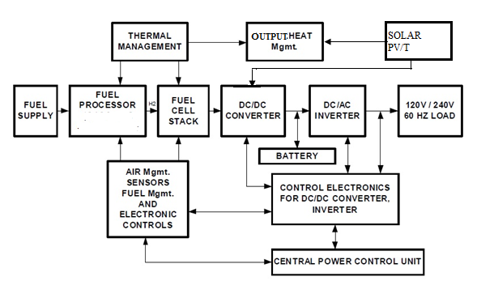
Fig.9 Smart energy conversion
A 42 to 48V battery is connected to the output terminals of the DC-DC converter to provide additional power at the output terminals for motor startups, etc. During steady state, the DC-DC converter regulates its output to 50V and the battery operates in a float mode. The fuel cell and the DC-DC converter are rated for steady state power (say 10kW), while the DC-AC inverter section is rated to supply the motor-starting VA. Assuming a motor-starting current of 3 to 5 times the rated value, the DC-AC inverter rating will be in the 15kVA to 25kVA range. The DC-DC boost converter is operated in current mode control. During a motor startup operation, the current mode control goes into saturation and limits the maximum current supplied from the cell. During this time, the additional energy from the battery is utilized. During steady state operation, the fuel cell energy is used to charge the battery when the output load is low.

VII. CONCLUSION
The problem of food waste deposal will solve if it regularly collected and used in an anaerobic digester to produce biogas. The energy potential contained in biogas can be used to power fuel cell which produces quite and pollution free electricity, heat and hydrogen. The hydrogen generated by the system can be used for other purposes also like to power vehicles which are used to collect food waste from different places. The parabolic design of the solar PV/T system uses renewable solar energy to generate efficiently electricity and heat. The smart controller takes variable power either from fuel cell or from solar PV or from both to produce stable and reliable output power. The hybrid tri generation system effectively uses renewable biomass energy and solar energy to efficiently produce electricity, heat and hydrogen

References:
[1] Ostrem, K. & Themelis, Nickolas J "Greening Waste : Anaerobic
Digestion for Treating the Organic Fraction of Municipal Solid Waste",
2004, Available online

[2] Laclos, F. de, Desbois, H.S. & Saint-Joly, C.,"Anaerobic digestion of
Municipal Solid Organic Waste: Valorga full-scale plant in Tilburg,
NL",Water, Science Technology, 1997,36(6-7), pp.457-462.
[3] “Future Energy challenge” web site, http://www.energychallenge.org.
[4] IEA, “IEA Bioenergy” Task 37 Plant list 2008, Available online
[5] Chynoweth, D. and Isaacson, R. “Anaerobic digestion of biomass”,
1987): Springer, 1: 296.
[6] Delia, T. and Agdag, N.,“Co-digestion of industrial sludge with municipal
solid wastes In anaerobic simulated Land filling reactors”,:Process
Biochemistry, 2007, 40: 1871–1879.
[7] El-Mashad, H., Zeeman, G., Vanloon, W., Bot, G. and Lettinga, G,
“Effect of temperature and temperature fluctuation on thermophilic
anaerobic digestion of cattle manure”, Bioresource Technology, 2004:
95: 191-201.
[8] Hartmann, H. and Ahring, B. “Anaerobic digestion of the organic fraction
of municipal Solid waste: influence of co-digestion with manure”, Water
Resource, 2005: 39(8):1543-52. (1).
[9]“CEC published a guide to photovoltaic (pv) system design and
installation con-sultant report.California Energy Commission” A Guide
to Photovoltaic (PV) System Design and Installation report, (section
2.3.1):page 8
[10] Hamid RH El Hussainy F Beheary MM Elminir HK, Ghitas AE and Ab-
del Monein KM.,“Effect of dust on the transparent cover of solar
collectors”,.Energy Conservation and Management, 2006, 47:3192203,.
[11]S.C. SOLANKI A, SWAPNIL DUBEY A, ARVIND TIWARI B,
“Indoor simulation and testing of photovoltaic thermal (PV/T) air
collectors”, Applied Energy,2009, 86, 2421–2428,
[12]M. Junghänel, M. Schädel,L.,“BLACK MULTICRYSTALLINE SOLAR
MODULES USING NOVEL MULTILAYER ANTIREFLECTION
STACKS” eupvsec-proceedings, p.no. 9228
[13] Effendi A, Hellgardt K, Zhang Z-G, Yoshida T., “ Optimising H2
production from model biogas via combined steam reforming and CO
shift reactions.”, Fuel 2005;84:869e74.
[14] Kolbitsch P, Pfeifer C, Hofbauer H. , “Catalytic steam reforming of
model biogas.”, Fuel 2008;87:701e6.
[15] Ruckenstein E, Hu YH., “ Methane partial oxidation over NiO/MgO
solid solution catalysts.”, Appl Catal A Gen.,1999;183:85e92.
[16] Souza MMVM, Schmal M., “ Autothermal reforming of methane over
Pt/ZrO2/Al2O3 catalysts.,” Appl Catal A Gen 05;281: 19e24.,
1999;183:85e92.
[17] Trimm DL., “Catalysts for the control of coking during steam
reforming.”, Catal Today 1999;49:3e10.
[18]“What Are Batteries, Fuel Cells, and Supercapacitor.” Chem. Rev. 2004,
104, 4245-4269
[19] Ljupka Arsova “Anaerobic digestion of food waste: Current status,
problems and an alternative product”, PhD thesis,2010

